3 Tier architecture to host Web application (MERN stack) in HA, secured environment

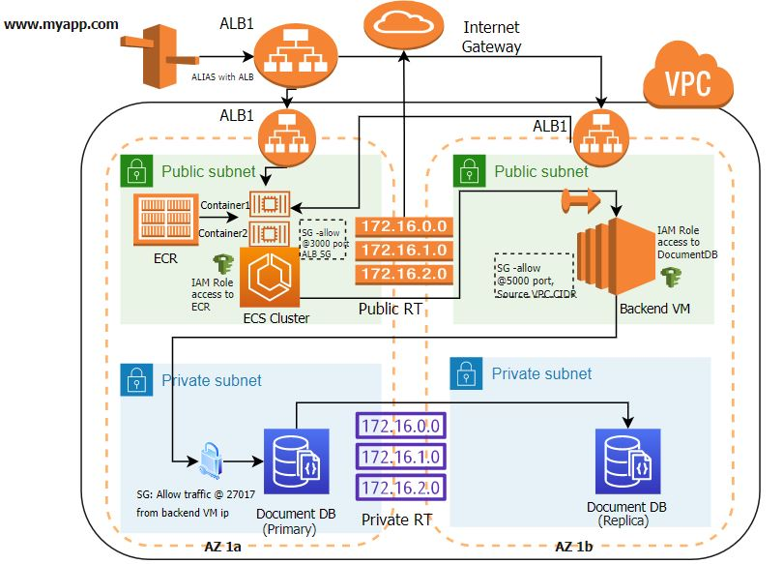

Application (MERN stack) deployed in HA, secure environment

1. Created VPC with CIDR 172.0.0.0/16
2. Two private subnets and public subnets were created in two availability Zone
3. Created public route table , associated with public subnets where traffic going to destination 0.0.0.0/0 (all traffic) is targeted to **Internet Gateway**
4. Created private route table, pointing to private subnet
5. Created one ECS cluster in public subnet – AZ 1A **with two containers (pulled image from ECR)** to host **frontend application (in React.JS)**

* Dockerize React application and its dependency
* Run Docker build command to create image
* Tag docker image with ECR registry
* Run Docker push to push image to ECR registry
* Created ECS task to point to ECR image
* Created ECS service to run two tasks which will run front end application
* Created Application load balancer(having dynamic port mapping feature) to load balance traffic to two containers

1. Created another EC2 instances in public subnet – AZ 1b to host

* **back end application in Express framework** and install **Node** there as well

1. Created Elastic IP for backend application
2. Have EIP of backend application coded in frontend application , so that it can invoke backend API
3. Created Document DB (MongoDB engine 4.0) cluster in private subnet (one primary DB and another Replica)
4. IAM role is created for backend application to access Document DB, **enhancing security**
5. Back end application is coded to access Document DB URI using mongoose package and also certificate is installed to access document DB securely from application program
6. All these application endpoints and database endpoint are having security group in front. So traffic coming from internet has to meet SG to access application/DB
7. Also created route 53 ALIAS record to map ALB

Thus [www.myapp.com](http://www.myapp.com) (not actual name, actual application is shutdown to not incur server cost) **is able to securely communicate with DB (hosted in private subnet) in high availability environment.**